**DAILY ONLINE ACTIVITIES SUMMARY**

|  |  |  |  |  |  |  |  |
| --- | --- | --- | --- | --- | --- | --- | --- |
| **Date:** | **09/06/2020** | | | | **Name:** | **Namratha C** | |
| **Sem & Sec** | **8th sem, A sec** | | | | **USN:** | **4AL16CS056** | |
| **Online Test Summary** | | | | | | | |
| **Subject** | | **BDA** | | | | | |
| **Max. Marks** | | **26** | | **Score** | | **30** | |
| **Certification Course Summary** | | | | | | | |
| **Course** | **AWS Development Tools Services Overview** | | | | | | |
| **Certificate Provider** | | | **Aws training and certification** | **Duration** | | | **5mins** |
| **Coding Challenges** | | | | | | | |
| **Problem Statement: 1) Python program to find a list of uncommon words** | | | | | | | |
| **Status: Completed** | | | | | | | |
| **Uploaded the report in Github** | | | | **Yes** | | | |
| **If yes Repository name** | | | | **CODES (Namrathasonu)** | | | |
| **Uploaded the report in slack** | | | | **Yes** | | | |

Online Test Details:

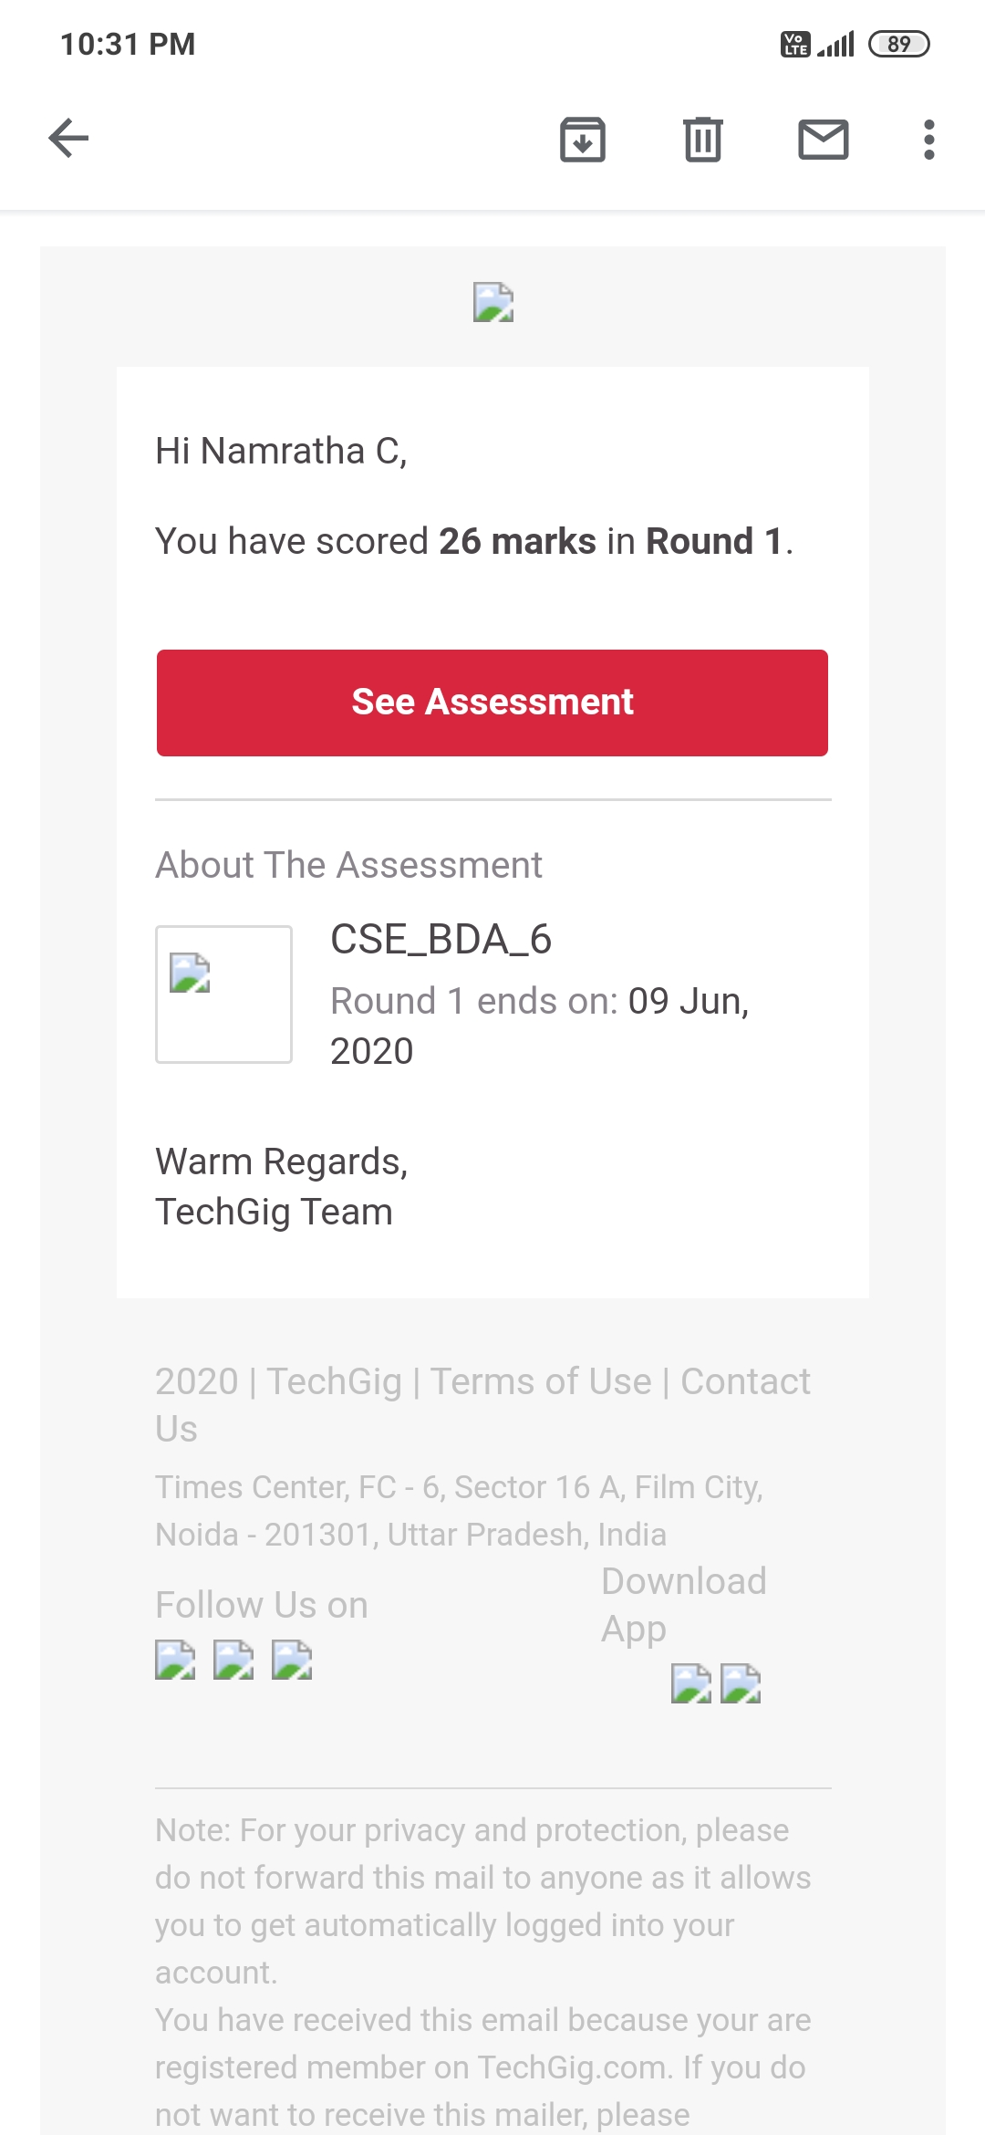

Certification Course Details:

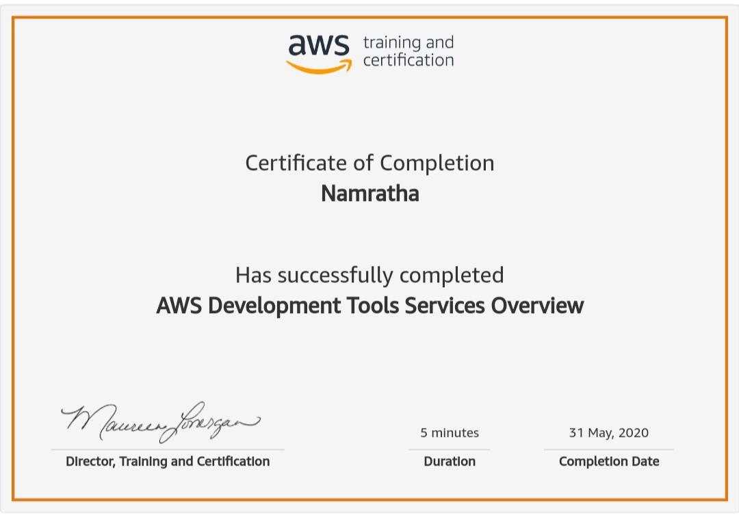

Coding Challenges Details:

1)

def UncommonWords(string1, string2):

count = {}

for word in string1.split():

count[word] = count.get(word, 0) + 1

print(count)

for word in string2.split():

count[word] = count.get(word, 0) + 1

print(count)

return [word for word in count if count[word] == 1]

string1 = "Hello World"

string2 = "Hello Everyone"

print(UncommonWords(string1, string2))